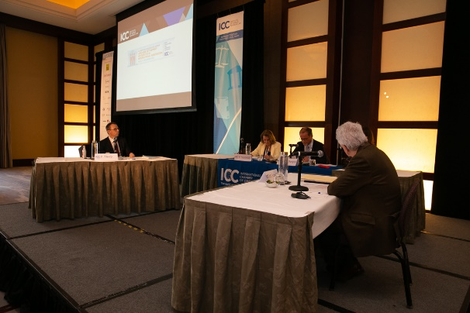

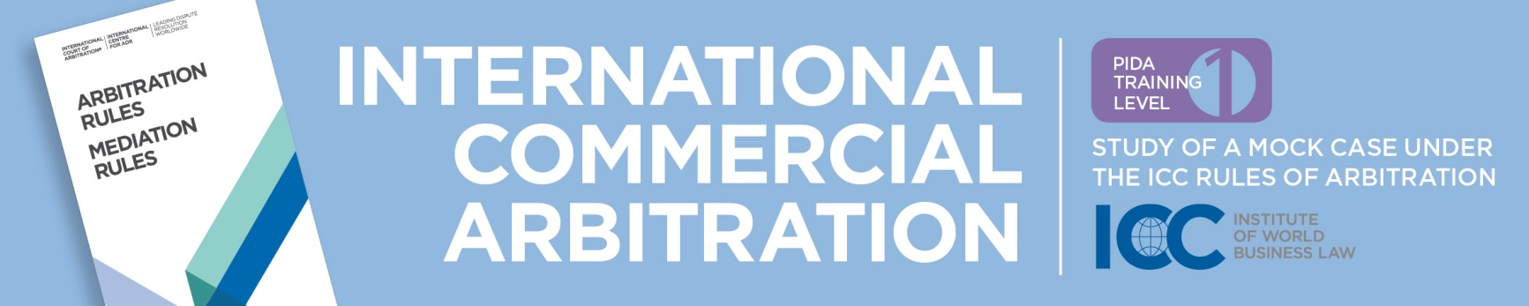

Local Partner Supported by
20–22 APRIL 2019

Venue: Ho Chi Minh City University of Law 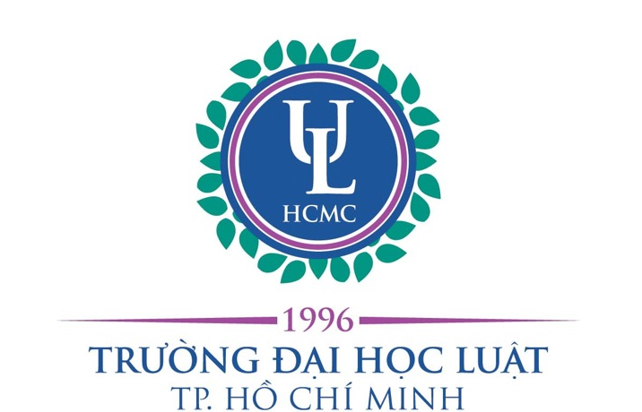


Registration Form

Surname |  | First Name
Gender |  | Post Qualification Experience (Years)
Company |  | Position
Telephone |  | Email Address
The data collected with your registration is processed electronically by ICC as data controller. Your file is managed confidentially and may be communicated to colleagues within the ICC interested in your registration. Concerning your personal data, you have the right to query access, and to rectify or delete personal data. You also have the right to restrict processing or to object to the processing as well as the right to data portability. To exercise your rights, you are invited to contact mingchao.fan@iccwbo.org. If you are not satisfied with this reply, you can contact the Data Protection Officer (DPO) of ICCdataprotection@iccwbo.org, together with the proof of your ID. If you feel, after contacting us, that the rights to your data are not respected, you can submit a complaint to the CNIL https://www.cnil.fr.

